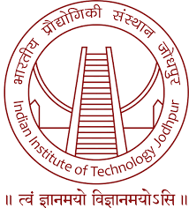
Malaviya National Institute of Technology Jaipur

REGISTRATION FORM
SPARC Sponsored, One Week International Workshop on
“Fundamentals of HEAs and its Application”
15-19 July 2024

Name: Mr./Ms/Dr._____________________________________________________________
(In capital letters)

Designation/Department/Organization: _____________________________________________

______________________________________________________________________________

Address for Correspondence: ______________________________________________________

_____________________________________________________________________________

E-mail ID: ______________________________________Mob. No.______________________

Field of Specialization: __________________________________________________________

Experience: ______________ (in years)

Details of fees ________________________________Cash/DD/NEFT ____________________

Signature _________________________ Date _______________________________________

Bank Details:
A/c Name: Registrar (Sponsored Research), MNIT Jaipur
A/c no.: 676801700388
Bank Name: ICICI Bank Ltd., MNITJ
IFSC Code: ICIC0006768

